Impact Evaluation

January 2018-January 2019

Dear Friends,

With the rising number of young people experiencing mental health difficulties and being exploited because of their vulnerabilities, it is so important that our work through FREEDOM 2 continues. On the positive side, we are not alone in this fight and there are other organisations in the UK who are raising awareness and helping those who have been affected by exploitation in some way.

Our vision is that every girl will be free from exploitation, have a voice, know their worth and significance, reach their potential and empower others. Our programmes are designed around our vision, so that we can help girls to feel confident in who they are and how they live their life, so they can reach their potential and inspire others around them.

A highlight from 2018 is that we started our second programme, FREEDOM 2 Create, which is art sessions run over 7 weeks. The pilot courses that we have run in Redbridge schools have been very successful.

We are looking forward to continuing our work in 2019 and being able to make a positive impact to the lives of the girls in East London. I hope from reading this report that you will understand the passion of the work that we do and see the impact of what we do.
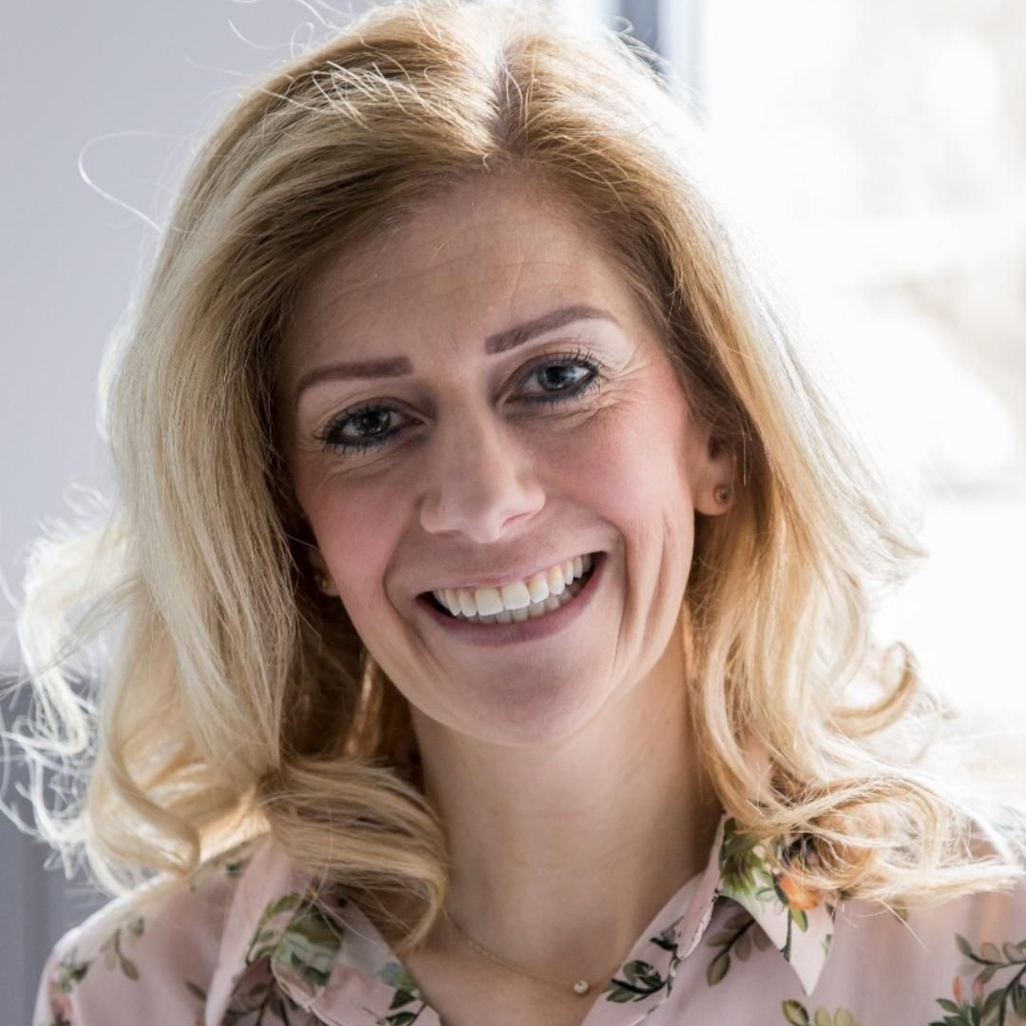

Melanie Manning
Chief Operations Officer

Executive Summary:

Introduction:

The purpose of this report is to evaluate the two programmes that we currently deliver, FREEDOM 2 Girls (8 weeks) and FREEDOM 2 Create (7 weeks) from January 2018 to January 2019.

The way that we have collected the data is by asking the beneficiaries that attend the course to fill out The Warwick Edinburg Mental Well-being Scale at the beginning of each course and then at the end of the course. This information has then been collated.

For FREEDOM 2 Create, girls are also asked to self-assess at the end of each session on their Journey to FREEDOM form, which is stuck in their art journals.

At the end of each course the beneficiaries are asked to fill out a general evaluation form to find out how they found the course and if they have any suggestions on how to make the course more enjoyable for them.

Findings and Discussion:

Three schools in Redbridge were visited during this period, Wanstead High, Caterham High and Valentines. The data below shows how many girls attended each course.

1. Wanstead High
Spring term 2018 – 4 girls
Autumn term 2018 – 6 girls

2. Caterham High
Spring term 2018 – 6 girls
Autumn Term 2018 – 3 girls

3. Valentines
Summer 2018 – 7 girls

Total: 26 girls

Results from The Warwick Edinburgh Wellbeing Scale

STATEMENTS | None of the time | Rarely | Some of the time | Often | All of the time
I’ve been feeling optimistic about the future | 1 | 2 | 3 | 4 | 5
I’ve been feeling useful | 1 | 2 | 3 | 4 | 5
I’ve been feeling relaxed | 1 | 2 | 3 | 4 | 5
I’ve been feeling interested in other people | 1 | 2 | 3 | 4 | 5
I’ve had energy to spare | 1 | 2 | 3 | 4 | 5
I’ve been dealing with problems well | 1 | 2 | 3 | 4 | 5
I’ve been thinking clearly | 1 | 2 | 3 | 4 | 5
I’ve been feeling good about myself | 1 | 2 | 3 | 4 | 5
I’ve been feeling close to other people | 1 | 2 | 3 | 4 | 5
I’ve been feeling confident | 1 | 2 | 3 | 4 | 5
I’ve been able to make up my own mind about things | 1 | 2 | 3 | 4 | 5
I’ve been feeling loved | 1 | 2 | 3 | 4 | 5
I’ve been interested in new things | 1 | 2 | 3 | 4 | 5
I’ve been feeling cheerful | 1 | 2 | 3 | 4 | 5

Analysis

School | Before (Ave. per pupil) | After (Ave. per pupil)
Wanstead High | 50 | 44
Valentines | 39 | 48
Caterham | 42 | 60
Caterham | 51 | 53
Wanstead High | 37 | 45

For all the programmes that we ran, average well-being increased apart from one (Wanstead High).

Strengths

The Warwick Edinburg Mental Wellbeing Scale is accessible for most of the girls but can be read and explained by the facilitator if necessary. It also measures emotional well-being over the last 2 weeks, so is not asking the girls to recall emotions that they might have felt in the past.

The fact that the same assessment is done at the end of the course is a good way of tracking emotional well-being.

Weaknesses

Not all of the beneficiaries are able to assess how they are feeling or might not recognise emotions that they are experiencing. Also, some of the girls might not be truthful about how they are really feeling, as they do not want people to know.

It is also important to state that not all of the girls completed the course, due to factors such as exclusions, illness or drop out, but evaluations were all completed by the remaining beneficiaries.

What have the girls taken away from the sessions?

“I have learnt to always value yourself and others and a lot of things are not needed to stress about. Listen to other people and talk to other people” (FREEDOM 2 Girls Year 11)

“I have learnt that I’m worth more than I see. I learnt to listen to my friends and to see how they feel” (FREEDOM 2 Girls Year 11)

“You shouldn’t really underestimate yourself and I should be more confident” (FREEDOM 2 Girls - Year 10 student)

“Always stay positive” (FREEDOM 2 Girls - Year 7 student)

“I have learnt to express my feelings” (FREEDOM 2 Create – Year 10 student)

“I have learnt how to cope with things when under stress and I feel more happy and confident about myself” (FREEDOM 2 Create – Year 10 student)

“I have learnt to be more optimistic” (FREEDOM 2 Create – Year 10 student)

“To be confident and love myself” (FREEDOM 2 Girls – Year 10 student)

Thanks:

Thank you to all of our volunteers and supporters who have made our work possible this year.

