Impact Evaluation

January 2019-January 2020

Dear Friends,

Thank you for your support and encouragement throughout 2019. We have had a fantastic year continuing our work in East London with teenage girls. We have also had the opportunity this year to run our FREEDOM 2 Create programme with a group of ladies that are being supported by the Medaille Trust. We have seen such value in being able to use creativity in recovery and to improve an individual’s mental health.

Our vision is clear, that we want every girl to be free from exploitation, have a voice, know their worth and significance, reach their potential and empower others. Our programmes are designed around our vision, so that we can help girls to feel confident in who they are and how they live their life, so they can reach their potential and inspire others around them.

A highlight from 2019 has been that we have been able to host 2 art exhibitions where the girls that we have been working with have showcased their work. One exhibition was based on social media and the other focused on body image. We wanted to give the girls a platform to talk about the things that matter to them. We had so many visitors to our exhibitions, such as the Mayor of Redbridge, the Past Mayor of Havering and various Councillors, which was fantastic.

Another highlight has been the introduction of our new ‘For the 1 Ambassador Programme’. This is for girls who have attended our programmes and who want to then share their experiences with their peers who will attend other programmes in their school. They will also represent FREEDOM 2 at events. The thought behind this was that we want to develop long term relationships with the girls and schools that we work with rather than running 1 course and then never returning. To link with the idea of helping ‘The 1’, we have also introduced a monthly blog by guest bloggers and how they help ‘The 1’.

We are looking forward to continuing our work in 2020 and being able to reach more girls in East London. We are grateful for all our volunteers and trustees who support our work and want to make an impact in their local community. To keep up to date with all that is happening with FREEDOM 2, please visit our website www.freedom2.org.uk
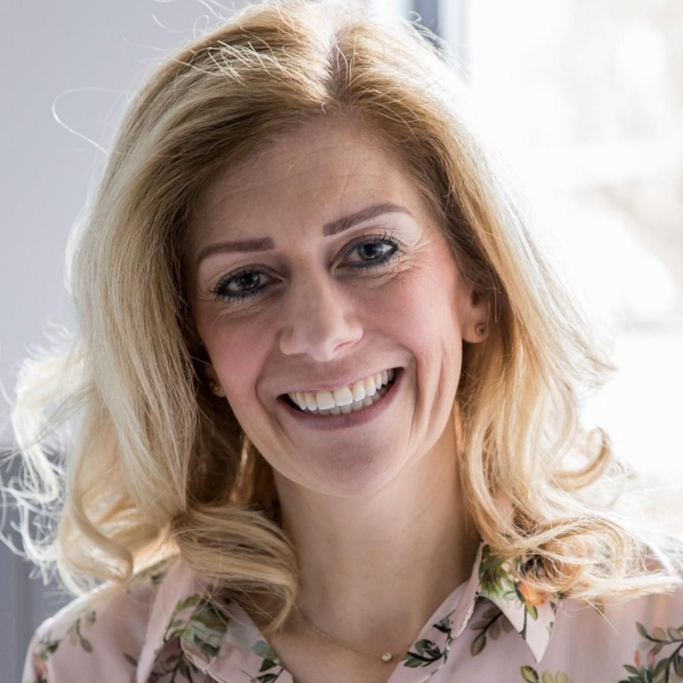

Melanie Manning
Chief Operations Officer

Executive Summary:

Introduction:

The purpose of this report is to evaluate the two programmes that we currently deliver, FREEDOM 2 Girls (8 weeks) and FREEDOM 2 Create (7 weeks) from January 2019 to January 2020.

The way that we have collected the data is by asking the beneficiaries that attend the course to fill out The Warwick Edinburg Mental Well-being Scale at the beginning of each course and then at the end of the course. This information has then been collated.

For FREEDOM 2 Create, girls are also asked to self-assess at the end of each session on their Journey to FREEDOM form, which is stuck in their art journals.

At the end of each course the beneficiaries are asked to fill out a general evaluation form to find out how they found the course and if they have any suggestions on how to make the course more enjoyable for them.

Evidence:

Art Exhibitions:

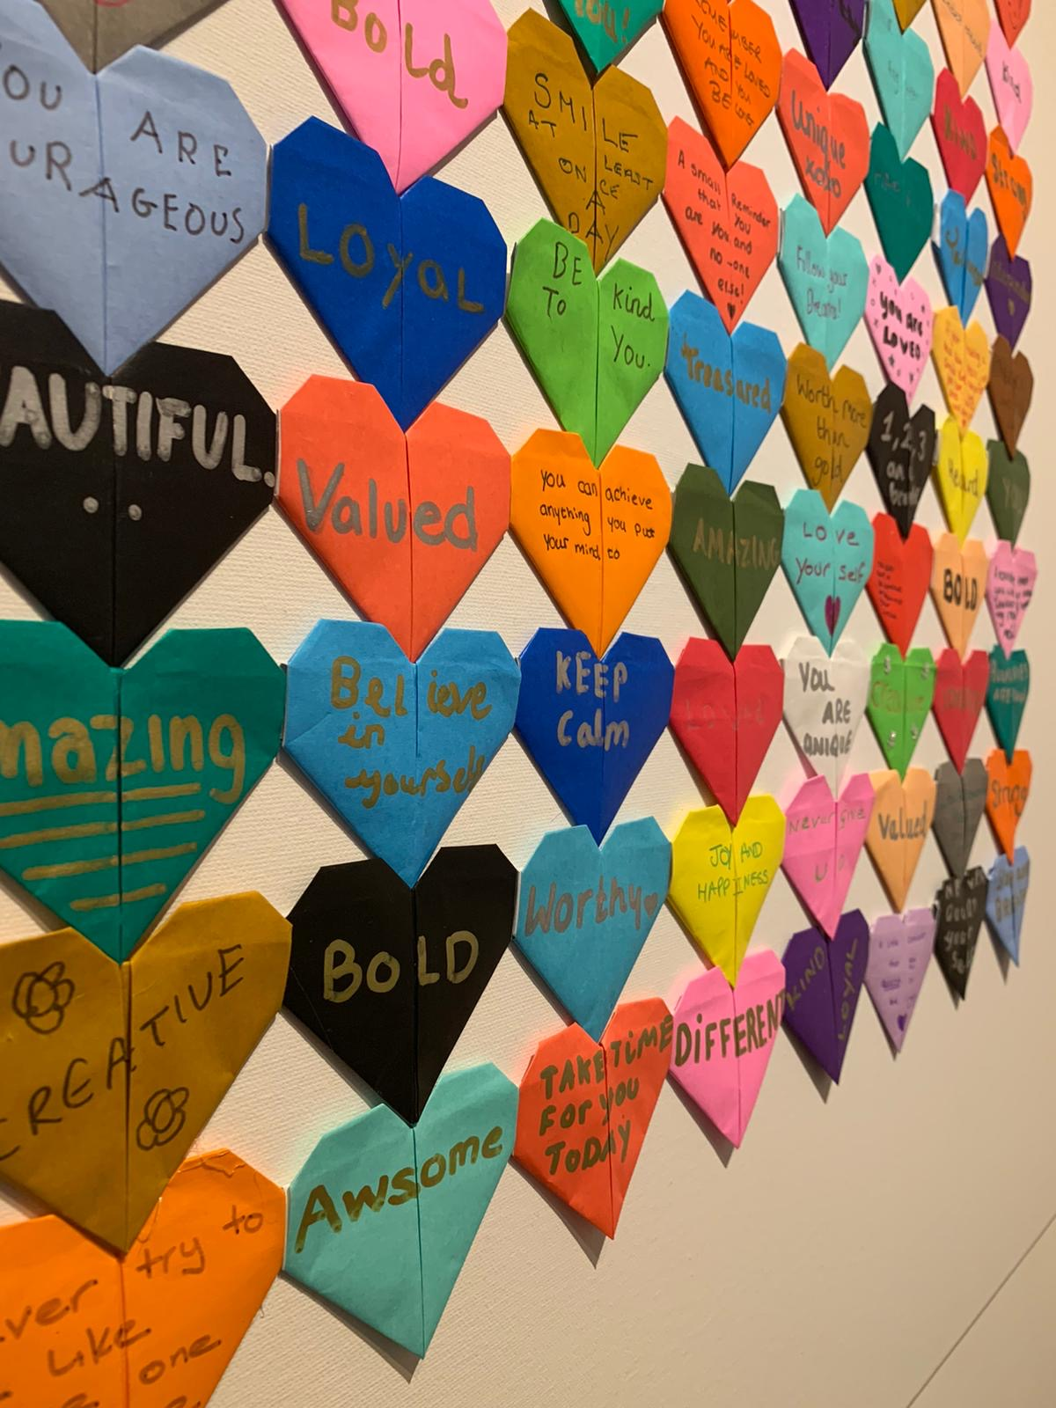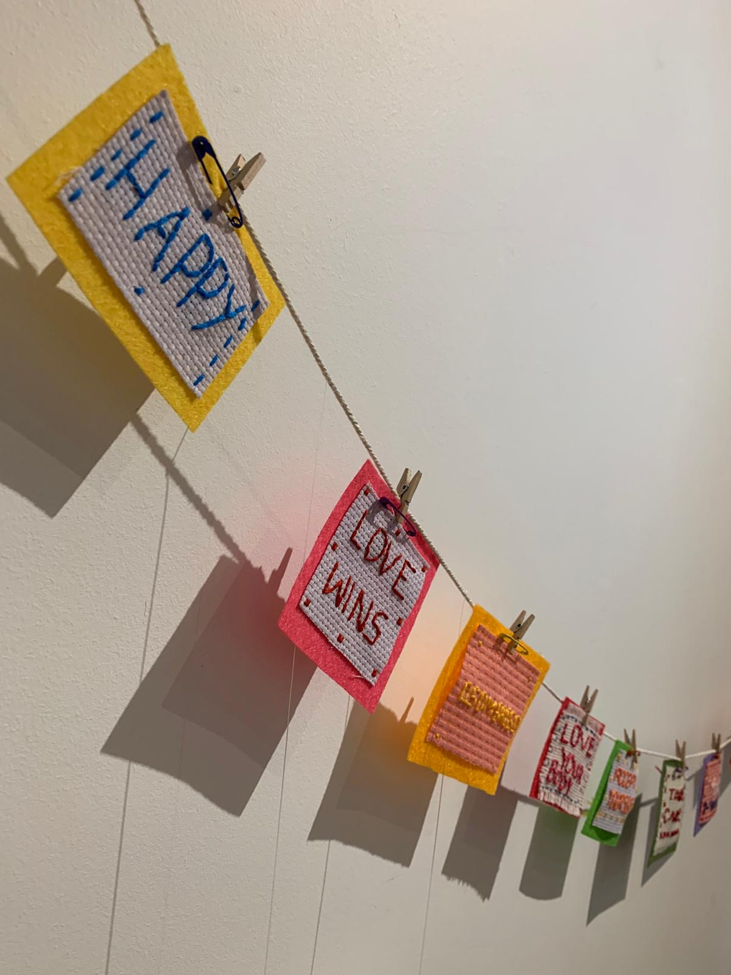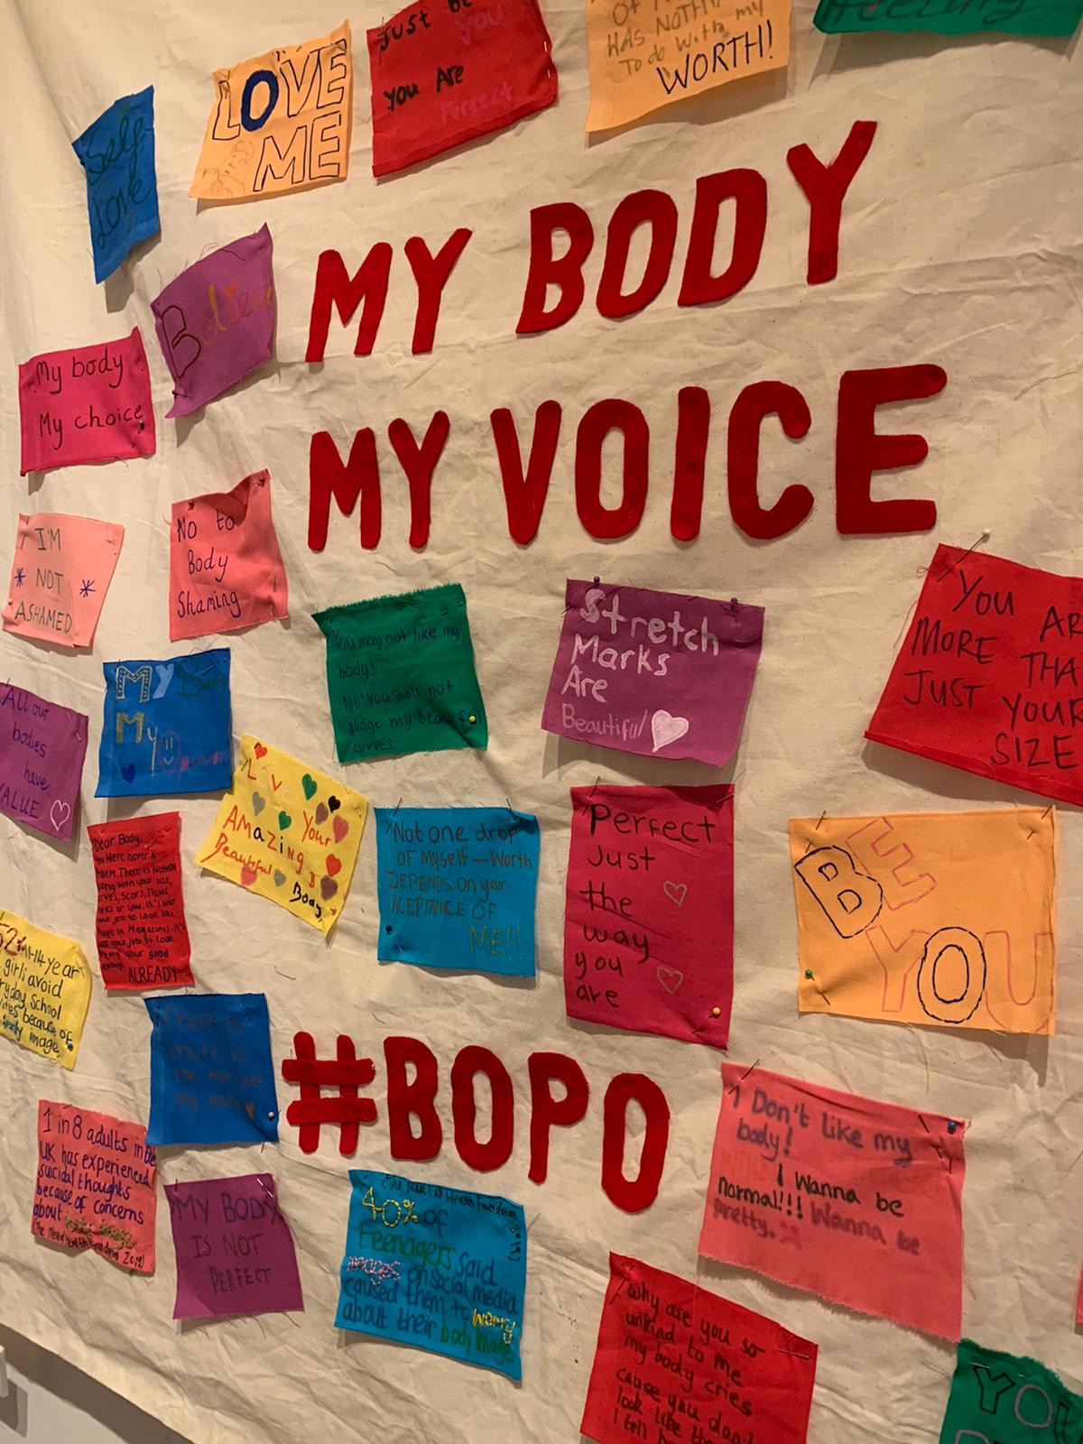

Sessions:
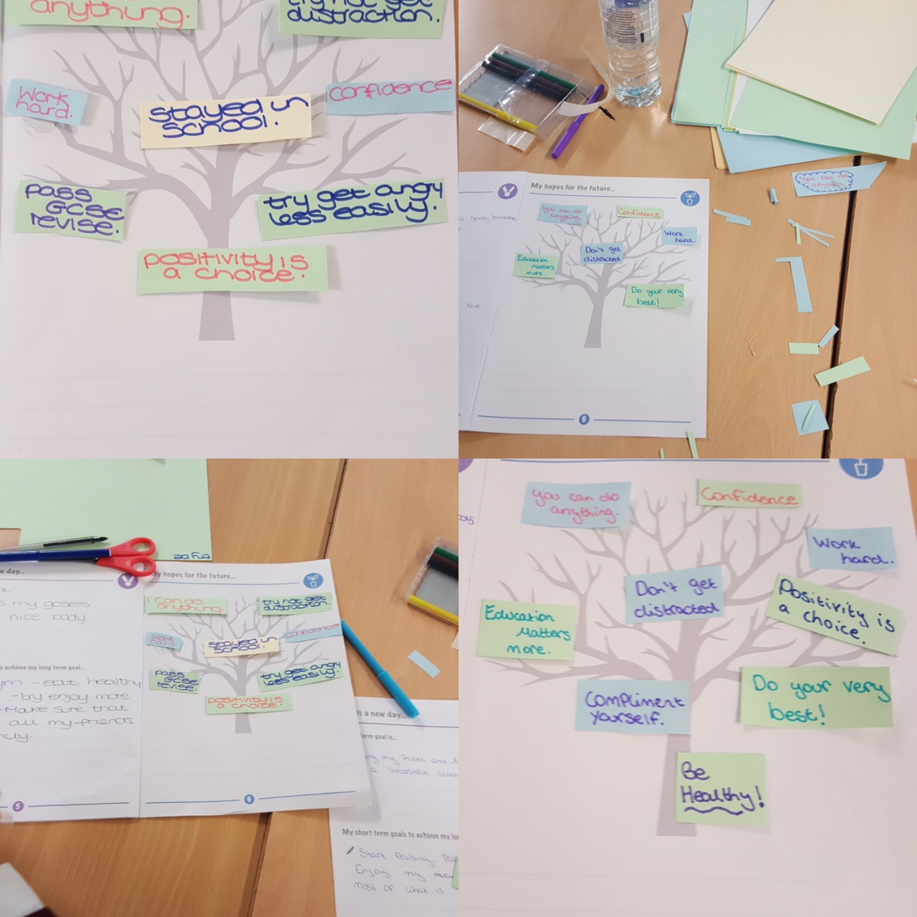
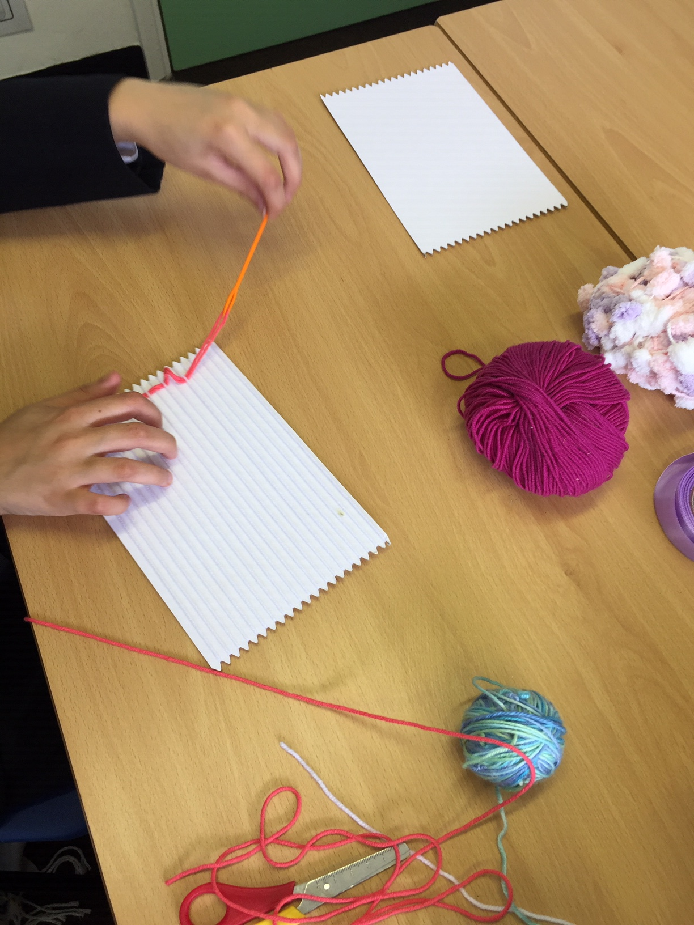
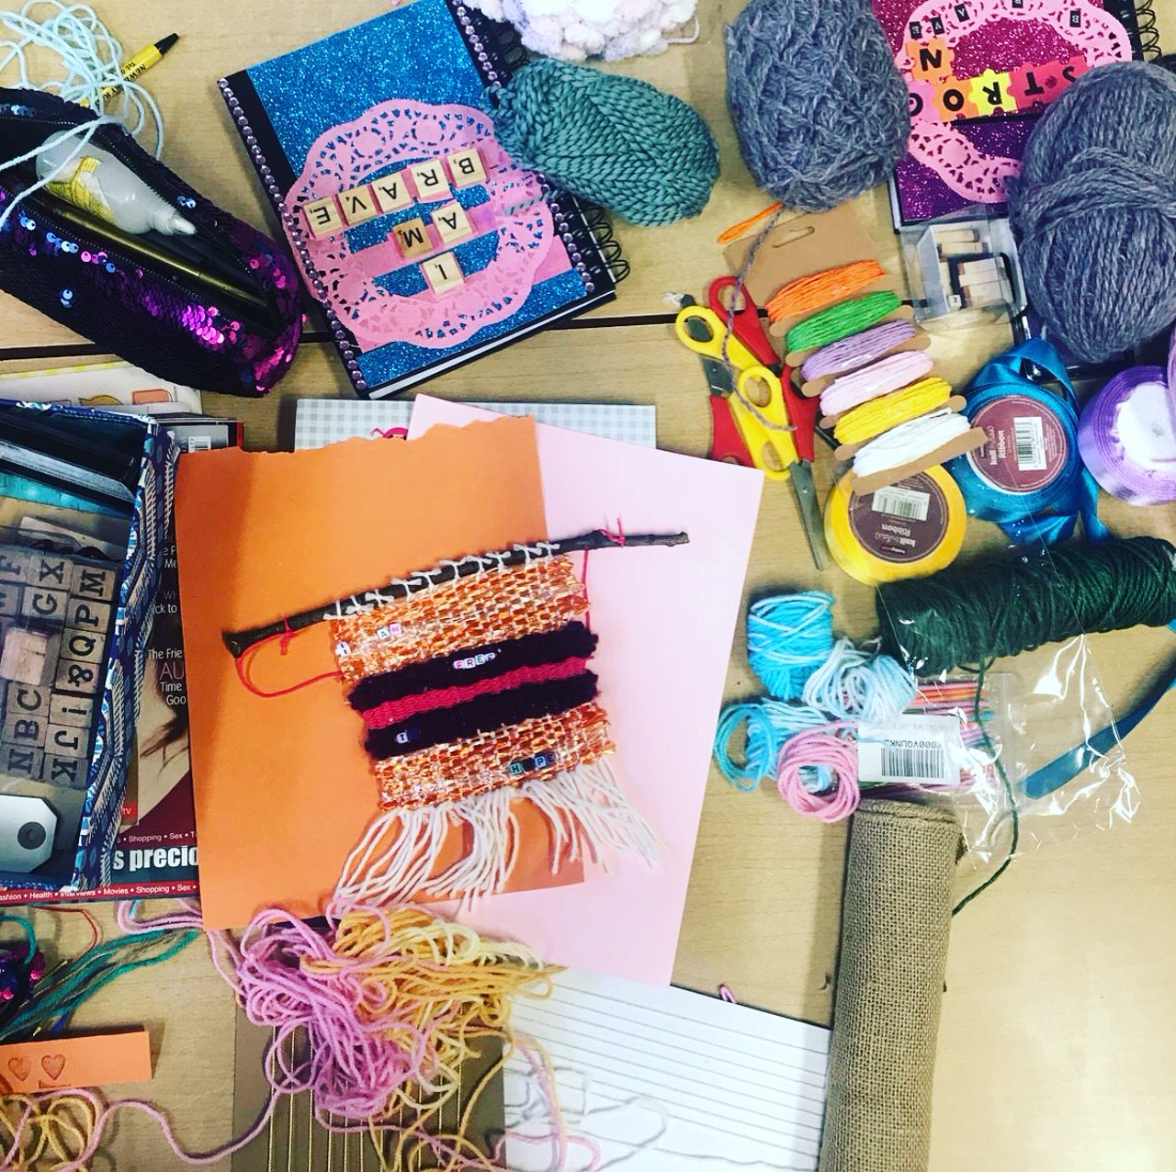

Findings and Discussion:

Five schools in Redbridge and Havering were visited during this period, Wanstead High, Caterham High, Valentines, Hornchurch High and Frances Bardsley. The data below shows how many girls attended each course.

1. Wanstead High
Autumn term 2019 (FREEDOM 2 Create) – 6 girls

2. Caterham High
Spring term 2019 (FREEDOM 2 Create) – 5 girls
Summer Term 2019 (FREEDOM 2 Create) – 8 girls

3. Valentines
Summer 2019 (FREEDOM 2 Create) – 6 girls (group 1).6 girls (group 2)

4. Hornchurch High
Summer 2019 (FREEDOM 2 Create) – 6 girls

5. Frances Bardsley
Spring 2019 (FREEDOM 2 Girls) – 5 girls
Summer 2019 (FREEDOM 2 Create) – 6 girls

Total:
2019 – 48 girls
10 women (plus 1 girl in group) – Total - 59
2018 - 26 girls

Results from The Warwick Edinburgh Wellbeing Scale

STATEMENTS | None of the time | Rarely | Some of the time | Often | All of the time
I’ve been feeling optimistic about the future | 1 | 2 | 3 | 4 | 5
I’ve been feeling useful | 1 | 2 | 3 | 4 | 5
I’ve been feeling relaxed | 1 | 2 | 3 | 4 | 5
I’ve been feeling interested in other people | 1 | 2 | 3 | 4 | 5
I’ve had energy to spare | 1 | 2 | 3 | 4 | 5
I’ve been dealing with problems well | 1 | 2 | 3 | 4 | 5
I’ve been thinking clearly | 1 | 2 | 3 | 4 | 5
I’ve been feeling good about myself | 1 | 2 | 3 | 4 | 5
I’ve been feeling close to other people | 1 | 2 | 3 | 4 | 5
I’ve been feeling confident | 1 | 2 | 3 | 4 | 5
I’ve been able to make up my own mind about things | 1 | 2 | 3 | 4 | 5
I’ve been feeling loved | 1 | 2 | 3 | 4 | 5
I’ve been interested in new things | 1 | 2 | 3 | 4 | 5
I’ve been feeling cheerful | 1 | 2 | 3 | 4 | 5

Analysis

School | Before (Ave / pupil) | After (Ave / pupil)
Hornchurch (Aut) | 39 | 37
Wanstead (Aut) | 46 | 47
Francis Bardsley (Aut) | 46 | 46
Caterham (Sp) | 54 | 62
Caterham (Sum) | 40 | 33
Valentines 1 (Sum) | 48 | 49
Valentines 2 (Sum) | 37 | 57
Overall | 44 | 47

For the majority of the groups, well being either stayed the same or increased by the end of the course.

Strengths

The Warwick Edinburg Mental Wellbeing Scale is accessible for most of the girls but can be read and explained by the facilitator if necessary. It also measures emotional well-being over the last 2 weeks, so is not asking the girls to recall emotions that they might have felt in the past.

The fact that the same assessment is done at the end of the course is a good way of tracking emotional well-being.

Weaknesses

Not all of the beneficiaries are able to assess how they are feeling or might not recognise emotions that they are experiencing. Also, some of the girls might not be truthful about how they are really feeling, as they do not want people to know.

It is also important to state that not all of the girls completed the course, due to factors such as exclusions, illness or drop out, but evaluations were all completed by the remaining beneficiaries.

What have the girls taken away from the sessions?

‘Keep doing what you are doing.’

‘Your all amazing and have helped me out so much, thank you! I will always remember this as an amazing high school experience.’

‘I think the people are nice and it makes me fit in more.’

‘I loved it because it’s like you can be free to say anything.’

‘There was no judgement throughout the weeks.’

‘It was really good and it made me realise we are not alone and there are people like me and to feel more special. I loved it thank you.’

‘I have learnt lots of stuff and it made me feel I can talk about my feelings.’

‘I’ve learnt that I can be inspired and I can inspire others. I’ve loved coming to Freedom 2 it also made me happy every time I’m here. Thank you!’

‘I liked how you get to speak to new people and share your feelings and get to know how they are feeling and being able to help them and good advice from different people. I liked discussing about friendships. As throughout life you are not going be friends forever. And being able to share their thoughts and different things.’

‘The people were so positive and would definitely recommend it to someone.’

‘I really enjoyed it and I think it calmed me as well as benefitted. The two ladies were very friendly and fun.’

‘Thank you for doing this. It is making me better as a person.’

‘I like it, it’s very motivational!’

Thanks:

Thank you to Redbridge Arts Council for part funding our FREEDOM 2 Create Programme in 3 schools and an exhibition. Thank you also to The National Lottery for fully funding 3 of our FREEDOM 2 Create Programme and an exhibition.

Also thank you to the ‘Movement for Good’ fund by Ecclesiastical Insurance. We were awarded £1,000 to fund our ongoing programmes.

We are eternally grateful to all of our supporters, people who donate, our volunteers and trustees, who sow so much time and energy into FREEDOM 2.

